CSS Task:

Let’s build the website of our mascot Zozor, our famous donkey . Zozor has decided to go on a trip around the world and his first stop will be... San Francisco! He thus wants to create a website for people to know about him and follow his journey around the world.

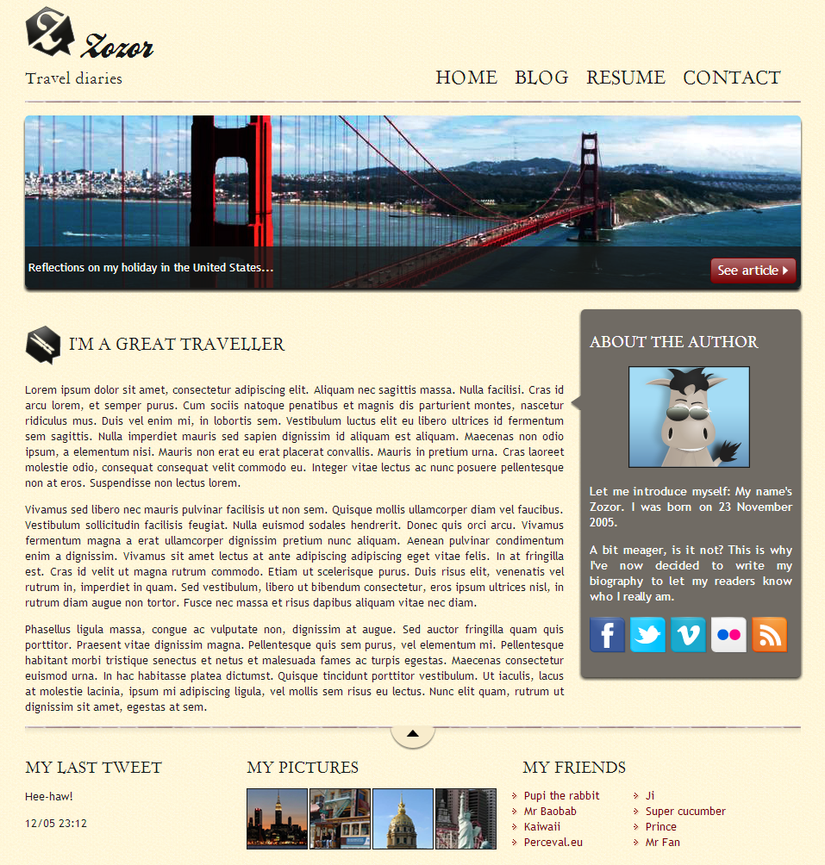Create a home page this way with HTML 5 and CSS tags to start with.

So all we have to do is build this website! We're going to proceed in two stages:

1. We're going to build the page **HTML** outline.
2. Then we're going to format it and do the page layout using **CSS**.

The first thing to do is to distinguish the main blocks on the mockup. These blocks will form the outline of our page.

To create the outline, we are going to use various HTML tags:

* the HTML5 structural tags, that we know:<header>,<section>,<nav>, etc. ;
* the general purpose<div>tag when there is no suitable structural tag.

How do I know which tag to use?

It's up to you to decide. Preferably use a tag that makes sense (such as the<header>,<section>,<nav>structural tags), but if no tag seems more appropriate to you, opt for the<div>generic tag.

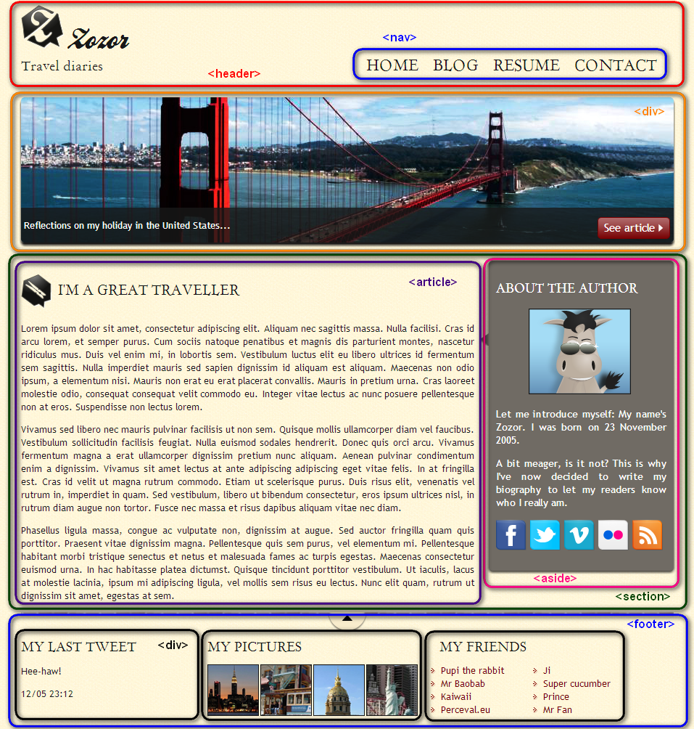

To deal with the CSS, look at the following items, in the order indicated:

1. Custom fonts.
2. Define the page's main styles (website width, background colour, default text colour).
3. Header and browsing links.
4. Banner (representing the San Francisco bridge).
5. Main section of the page's body, in the center.
6. Footer.